Z600 LED Video Processor Manual

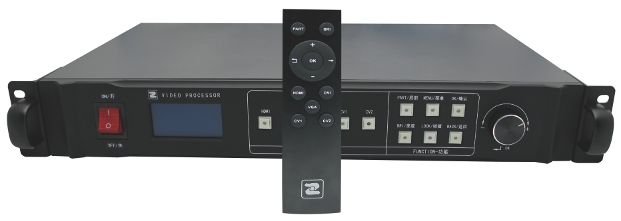

Contents
Chapter 1. Product Accessories 1
Chapter 2. Cautions 1
Chapter 3. Product Description 2
(1). Product Features 2
(2). Function Introduction 2
(3). Panel Diagram 3
(4). Technical Specification 4
(5). Instruction 5
(6). Standby Mode 5
(7). Main Menu Interface 6
(8). Advanced Menu Interface 7
(9). FAQ 9
(10). Remote Telecontroller Introduction 10

Chapter 1. Product Accessories
Qualified Certificate | User Manual
Remote Telecontroller | Antenna
Power Supply Wire | Free Gifts:  Signal Wire, Bolt and so on

Chapter 2. Cautions
1. Power supply input voltage range: 100~240VAC, 50/60HZ, please use correct power supply.
2. If you want to connect or unplug any signal wire or control cable, please confirm unplug all power supply cables first.
3. If you want to add or remove hardware to the device, please confirm unplug signal wire and power supply cable first.
4. Prior to any hardware operation, please turn off the power supply of LED video processor, and release the static on your body by touching the earth surface.
5. Please ensure that the using environment is dry, ventilated and clean, and keep the device away from high temperature or moisture environment.
6. This device belongs to electronic products, please keep away from fire source, water source, and inflammable and explosive dangerous products.
7. There is high voltage in the device. Nonprofessionals please do not open the case or repair the the device personally. Smoking or odd smell appears, unplug the power switch immediately and contact with dealer.

Chapter 3. Product Description

(1). Product Features
1. Support the maximum output resolution of 2304*1152, support user-defined.
2. Support five-channel HD signal input: HDMI, DVI, VGA, CVBS1, CVBS2.
3. Fade in/out effects, seamlessly switch between different input signals.
4. 3 picture modes: nature, vivid, soft.
5. Support image adjustment on brightness, contrast, saturation, and clarity.
6. Support OSD and adjust display time.
7. Support EDID manager.
8. Support dual mode key lock function.
9. Support built-in 2 pieces sending cards.
10. Support key, knob, and remote control multi-mode adjustment.
11. Remote control, with ultra-low-power and ultra-long-communication distance.
12. Standard 1.5U, convenient for carry and install.
13. Power supply voltage input range: AC 100~240V, 50/60HZ.
14. Support online system upgrades.

(2). Function Introduction

Overview
The device Z600 is a high definition(HD) video processor which is developed for LED large screen display system. It uses leading lossless zoom technique in the industry, supports 2 pieces sending cards which build-in the case and cascade in various ways, supports HD DVI/HDMI input and DVI output, and provides LED large screen HD display solutions to customers. Besides fast switching video signal source, the product simplifies the customer operation process which really achieves the minimalistic operation. In addition, remote telecontroller and OSD system, can realize the control mode in the open 500 meters distance and break the difficult situation when customers adjust screen. The ultra-low-power of remote telecontroller is 0.6mw. The LED screen doesn’t flash when zooming, and the screen is smooth and stable when switching part-screen or full-screen. The device provides multi-mode key lock, and more safe operation choice. Z600 system supports online upgrades which can offer new functions to customers.

(3). Panel Diagram

Front Panel Diagram
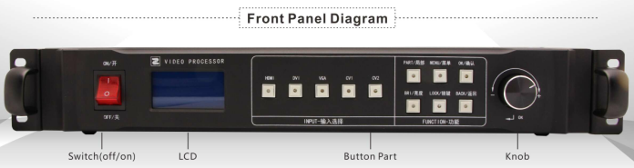
Switch | Power Supply Switch
LCD Screen | Display Detailed Operation Tips
Knob | Adjust LED Screen Resolution

Button Part
HDMI | HDMI Signal Input Option Key | PART | Part/Full Screen Switch
DVI | DVI Signal Input Option Key | MENU | Enter “Advanced Setup” mode
VGA | VGA Signal Input Option Key | OK | Confirm Key
CV1 | CV1 Signal Input Option | BRI | Brightness Adjust Key
CV2 | CV2 Signal Input Option | LOCK | Key Lock
 |  | BACK | Return to the Previous Menu

Back Panel Diagram
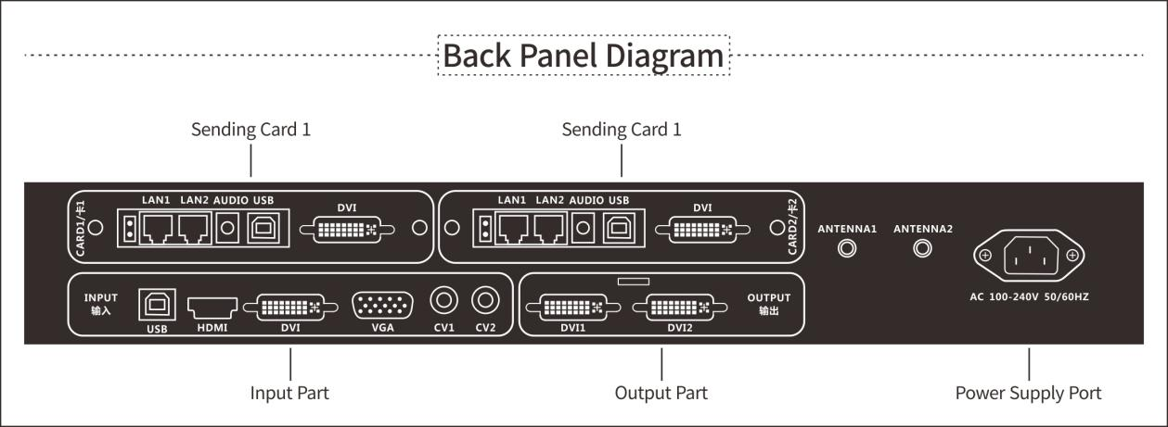

Signal Input Port |  | Signal Output Port
HDMI | HDMI Input Port | DVI1 | Output Port 1
DVI | DVI Input Port | DVI2 | Output Port 2
VGA | VGA Input Port
CV1 | CV1 Input Port
CV2 | Cv2 Input Port

(4). Technical Specification

Input Criteria
Port | Quantity | Resolution Specification
HDMI | 1 | EIA/CEA-861 Standard, meet HDMI1.3 Standard
DVI | 1 | Support 1920*1080/60HZ and so on, which meet the VESA standard resolution
VGA | 1 | Support 1920*1080/60HZ and so on, which meet the VESA standard resolution
CV | 2 | PAL/NTSC
Output Criteria
Port | Quantity | Resolution Specification
DVI | 2 | 1024X768/60HZ  1024X1280/60HZ  1280X720/60HZ  1280X1024/60HZ  1366X768/60HZ  1440X900/60HZ  1536X1536/60HZ  1600X1200/60HZ  1680X1050/60HZ  1920X1080/60HZ  1920X1200/60HZ  2048X640/60HZ  2048X1152/60HZ  2304X1152/60HZ  2560X816/60HZ

Device Specification
Input Power Supply | 100~240V AC 50/60HZ 0.3A
Operating Temperature | 0~45℃
Dimensions | 485 X 292 X 71mm（LxWxH）
Weight | 3.4KG

(5). Instruction
Dear users, the Z600 processor is equipped with a 128x64pixel blue base LCD display, which display clear menu prompt at each step of the operation, and display standby mode when there is no operation or operation timeout. Based on minimalism, the device sets up extremely simple operation mode. Next is detailed introduction which combine with LCD display menu.

(6). Standby Mode
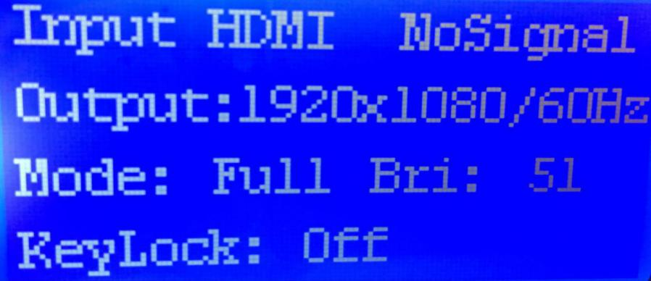
Input: display the current signal channel and the state. When signal normal, it shows the signal, when signal abnormal, it displays no signal
Output: display the set LED screen resolution
Mode: full-screen means display full computer desktop, part-screen means display screen capture part
Bri: current signal brightness level
Keylock: “menu lock” means function key lock, “full lock”means all key lock

(7). Main Menu Interface
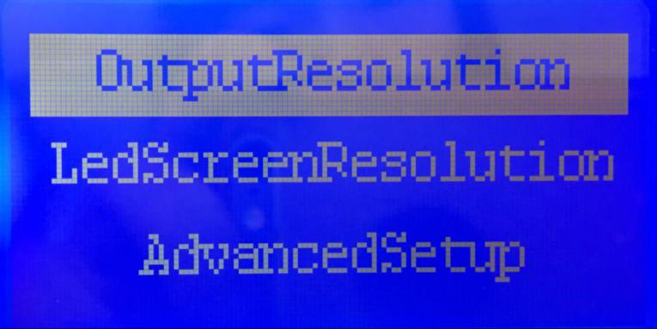
In order to achieve more efficient debugging, we offer the simple operation mode which just needs setting two parameters to make the larger screen display normal.
Options | Interface | Setup
Output Resolution | 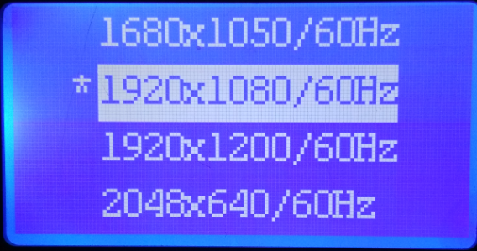 | Choose the resolution which is larger than the actual points of LED screen, support user-defined
LED Screen Resolution | 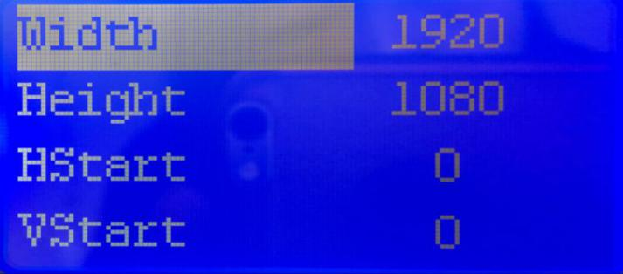 | Use knob to adjust the actual points of the LED screen

If the above two parameters’ setting is normal, then the basic operation is completed and the basic needs can be satisfied.

(8). Advanced Menu Interface
In order to meet the various requirements of customers, more options can be set under the advanced menu. Next is the function introduction of the various options in the advanced menu.
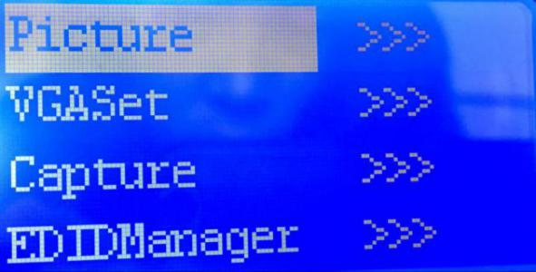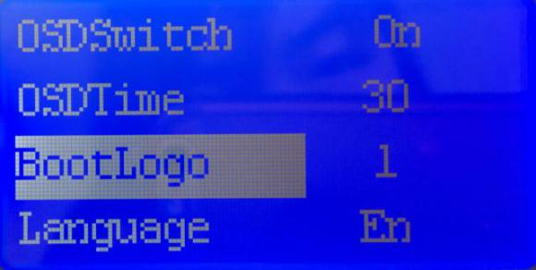
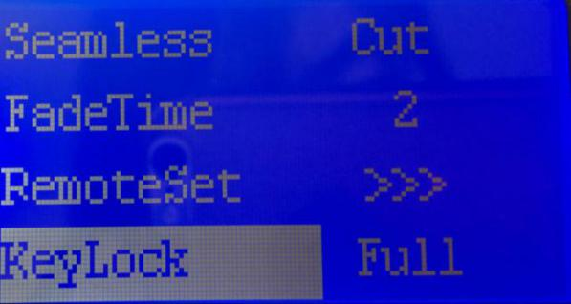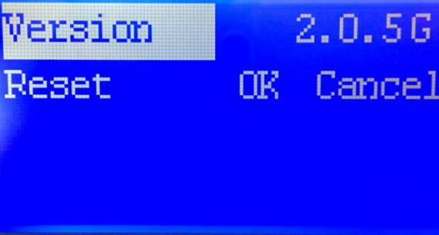

Picture Setup | 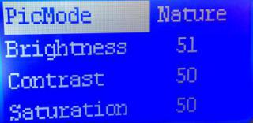 | 3 visual mode;  brightness, contrast, saturation, sharpness adjustment.
VGA setup | 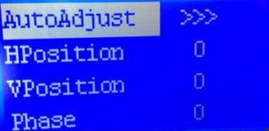 | Automatically adjust the VGA screen size, and manually adjust parameters.
Capture Setup | 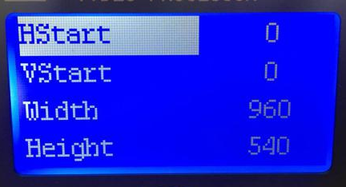 | Capture any part screen of the input signal source.
EDID Manager | 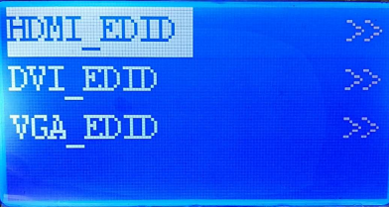 | Three-channel independent management.
Seamless Switch | Instantly switch  Fade in/out | Screen switching effects
Fade in Time | Time customized | Adjust the stay time when picture switch
Remote Setup | 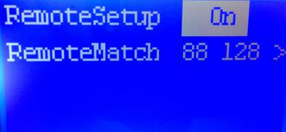 | Remote Switch/ Remote Match/Remote ID Display
Key Lock | Menu lock/ full lock | Lock function key/lock all key
OSD Switch |  | Turn On/off OSD
OSD Time | Unit: second | The time of OSD interface on the display
Start Logo | Start pictures choice | Start Logo: 1, 2, 3, close
Version | V2.X.X | Display device version
Factory Setup | OK/cancel | If you confirm, then the device will restore to the default setting parameters.

(9). FAQ

In the process of operation, it’s unavoidable to encounter some problems caused by incorrect operation. The following are the problems that users can debugging by themselves. If the methods don’t work, please do not dismantle the device and contact the distributor in time.
LCD doesn’t work | Confirm the power wire is plugged tightly and the power supply is normal.
The display of LED screen lack of color | Confirm the input/output signal terminal cables are plugged tightly, and tighten the screws.
The screen has black edges | 1. Adjust the output resolution larger than or equal to the LED screen physical pixel size.  2. Setup the computer resolution or EDID resolution to the maximum input resolution.  3. If the above operations don’t work, then enter the graphics card setup interface, adjust the extended display (PROCESSERDVI/ PROCESSERVGA) screen, zoom to full screen.
The VGA signal display is incomplete | - Main Menu-Advanced Setup-VGA Setup-Auto Adjust-OK. (if the adjustment is still incomplete, then repeat the automatic adjustment process.)  - Manual adjust H Start/V Start/ Clock Size parameters.
Remote telecontroller doesn’t work | Make sure the remote antenna is assembled in an open position.  Main Menu - Remote Setup:  1. Restart the remote control switch.  2. Enter the “Remote Match” interface, and press the “BRI” and “OK” keys at the same time in the remote telecontroller, then the interface will display a successful matching prompt.
Device connection debugging is complete, while appear the black screen | 1. Confirm that the signal source button is selected correctly. (if the button indicator light is always on, then the signal is normal; if the button indicator light is flashing, then the signal is abnormal)  2. Confirm that the input source computer whether in hibernation mode.  3. Check the signal source if it is exist or not.  4. Switch to full screen mode, if normal, check whether the screen capture area is black area.

(10). Remote Telecontroller Introduction

For the user’s better operation,we supply remote telecontroller which is convenient and efficient. After “Remote Match”, you can control the video processor within 500 meters.
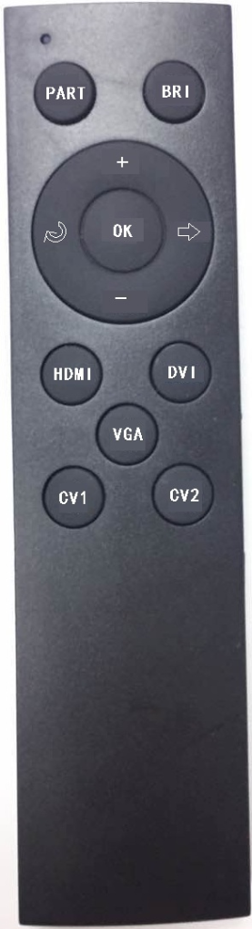
Keycode Description
Keycode | Function
PART | Part-screen
BRI | Brightness
+ | Number+, Page +
- | Number-, Page -
 | Back/Return
 | Enter
OK | Confirm
HDMI | Switch to HDMI Signal Source
DVI | Switch to DVI Signal Source
VGA | Switch to VGA Signal Source
CV1 | Switch to CV1 Signal Source
CV2 | Switch to CV2 Signal Source
OK+BRI | Remote Match

